**Mohamed Abdelfattah – 2400027**

**Hesham Abozeid – 2300332**

**Mohamed Ahmed Salah – 2201650**

**Mid-term Report**

**Project title:**

Enhancing Alzheimer’s disease classification using Image Processing techniques and CNN model.

**Introduction:**

Alzheimer's Disease (AD) is a progressive neurodegenerative disorder that significantly impacts cognitive function and memory. Early detection and diagnosis are crucial for timely intervention and potential disease management. This report presents an AI-based approach to detect Alzheimer's disease using Magnetic Resonance Imaging (MRI) scans.

**Project Overview:**

We will use the AD dataset from ADNI in kaggle website [2].

We will apply noise on clear images then will use IP techniques as histogram equalization and bilateral filter to remove the noise and increase the contrast stretching, then we will compare the results with origin images and finally we will pass the origin images, noisy images and enhanced images and compare between results through the AI model that will be trained by the same dataset.

**Results**

**IP techniques**

**AI model**

**Noisy images**

**Literature Review:**

There are many studies that have dealt with the same problem and tried to contribute to increasing the accuracy of diagnosis for similar or different diseases as paper “A bilateral filtering-based image enhancement for Alzheimer disease classification using CNN”, we will try to apply more filters on noisy images to deal with most causes that happens in image acquisition stage to improve the detection accuracy as possible. [1]

**Methodology:**

1. **Image Preprocessing:**

* **Noise Reduction:**
  + Applied noise reduction techniques (e.g., Gaussian filtering, Median filtering and Bilateral filtering) to enhance image quality.
* **Normalization and Contrast stretching:**
  + Standardized image intensities to improve model performance (e.g., Histogram equalization).
* **We will apply these IP steps:**
  + **Median filter:** Reduces noises such as salt-and-pepper noise.
  + **Bilateral filter:** it helps remove noise while preserving fine edges and details in the image.
  + **Gaussian filter:** To smooth the image overall and reduce noise. It is useful when there is continuous noise or gradual changes in the image.
  + **Histogram equalization:**  It will be used to improve the contrast in an image, especially if the image is dark or not contrasting enough. This filter distributes the colors or grayscale evenly in the image, we used it after removing noise so that it does not apply additional noise.
  + **Skull stripping:** It helps extract brain tissue from the skeleton, making it easier to focus on the tissue of interest for analysis.
  + **Unsharp masking:** To decrease blurring level.

**2- Model Selection and Training:**

* **SVM (Support Vector Machine):**
  + A powerful model for binary and multi-class classification, SVM works well with high-dimensional data and can find optimal decision boundaries, but requires manual feature extraction and is sensitive to noisy data.
* **Random Forest:**
  + An ensemble learning method that combines multiple decision trees, RF handles complex data, is robust to overfitting, and provides feature importance, but it also requires feature extraction and is less interpretable.
* **CNN (Convolutional Neural Network):**
  + A deep learning model ideal for image classification, CNN automatically extracts features from raw images and excels at handling complex patterns in large datasets, but requires substantial data and computational power.
* We will decide which to use after getting the results to select the best model with best metrics.

**Data Collection and Preprocessing:**

* **Source:** Kaggle Alzheimer's Disease Neuroimaging Initiative (ADNI) dataset.
* **Size:** Approximately 18,000 MRI images.
* **Classes:**
  + Alzheimer's Disease (AD) – 8,346 Images
  + Mild Cognitive Impairment (MCI) – 1,115 Images.
  + Normal Control (NC) – 8,650 Images.
* **Processing Steps:**
  + 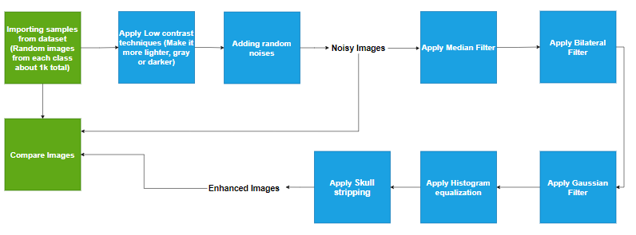**For IP:**
  + 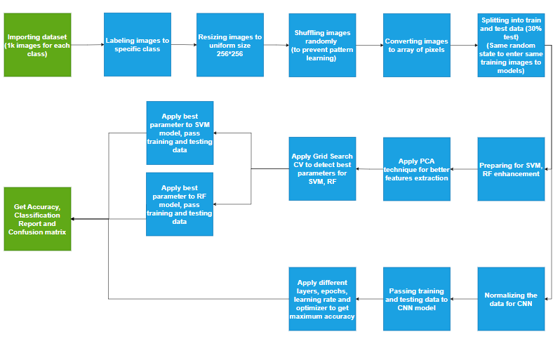**For AI:**

**Implementation Details:**

* **Programming languages:** We will use Python as it contains many libraries and functions that help in enhancing images and creating artificial intelligence models.
* **Libraries:** We will need some libraries in Python for IP as:
  + cv2 and PTL: for images.
  + numpy : for image converting to data.
  + matplotlib and seaborn: for displaying graphs.
  + sklearn: for machine learning & data preprocessing.
  + tenserflow: for Deep learning
  + Other libraries for special tasks.

**Experimental Design:**

**For IP:**

1. **Histogram**: check the distribution of the image.
2. **PSNR** **(Peak Signal-to-Noise Ratio):** Measures noise reduction quality. Higher values indicate better noise suppression.
3. **SSIM (Structural Similarity Index Measure):** Assesses structural similarity to the original image. Values closer to 1 indicate higher similarity.
4. **Mean pixel intensity, contrast, and entropy**.

**For AI:**

1. **Accuracy**: Percentage of number of correct classified sample to total number of samples.
2. **Precision:** The proportion of predicted positive cases that are actually correct. It measures the accuracy of the positive predictions made by the model.
3. **Recall:** The proportion of actual positive cases that are correctly identified by the model. It measures the model's ability to detect all relevant instances.
4. **F1-score:** Combination of Recall and Precision.

**Focus on Recall:** Prioritized the correct identification of AD cases to enable early intervention

**Results and Analysis:**

**For IP:**

* + First we applied **very high** random noise & contrast corruption on samples images from the 3 classes from the dataset.
  + 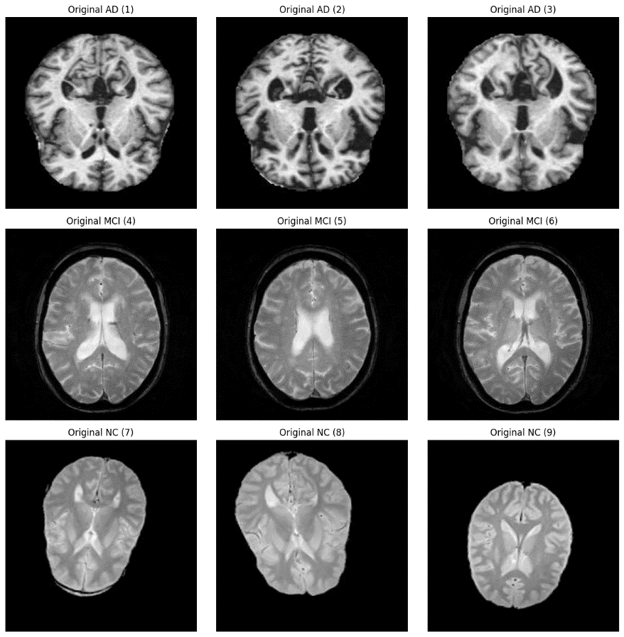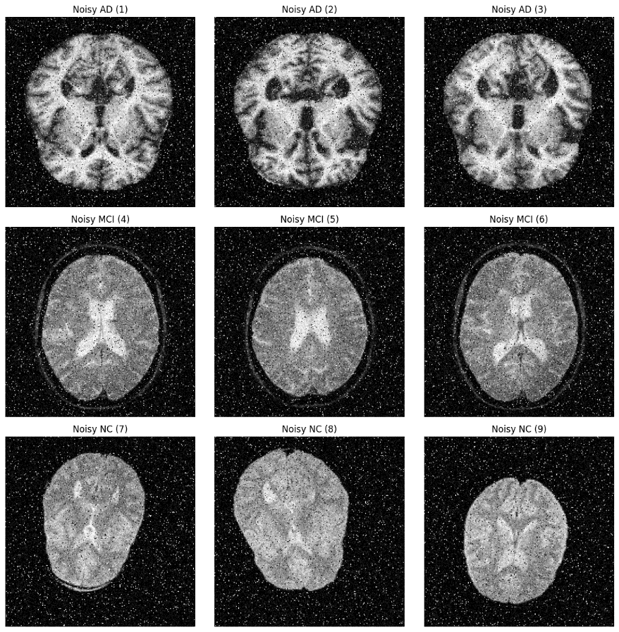Original images vs noisy images:
  + Then we compared every filter on the noisy images to see which one will act better.
  + Performance Metrics after enhancing noisy images:

|  |  |  |
| --- | --- | --- |
| Filter Type | PSNR | SSIM |
| Bilateral Filter | 17.87 | 0.22 |
| Median Filter | 25.47 | 0.48 |
| Gaussian Filter | 20.45 | 0.31 |

* + Third we will apply IP steps as we shown before (Median, Bilateral, Gaussian):

|  |  |  |
| --- | --- | --- |
| Filter Type | PSNR | SSIM |
| Suggested Filters | 25.79 | 0.51 |

* + Apply Histogram Equalization and Skull stripping.
  + Histogram and Image sample of origin sample vs noisy vs enhanced:

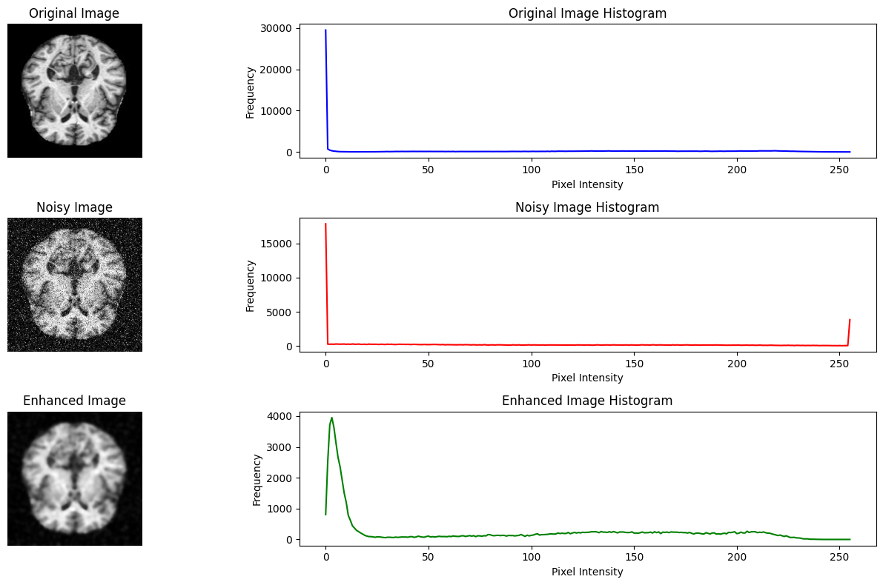

* + Apply skull stripping:

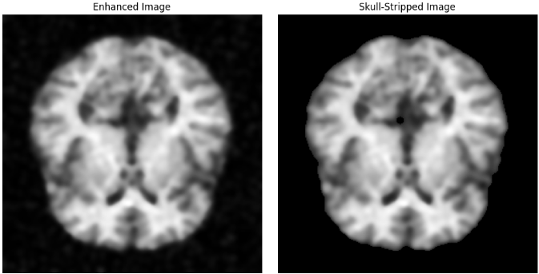

* + Apply unsharp mask to reduce blurring:

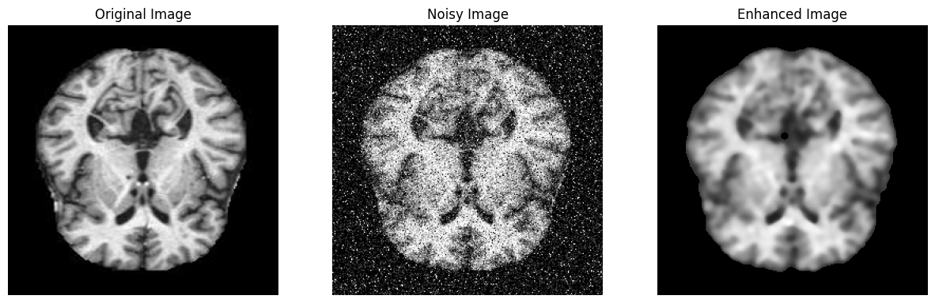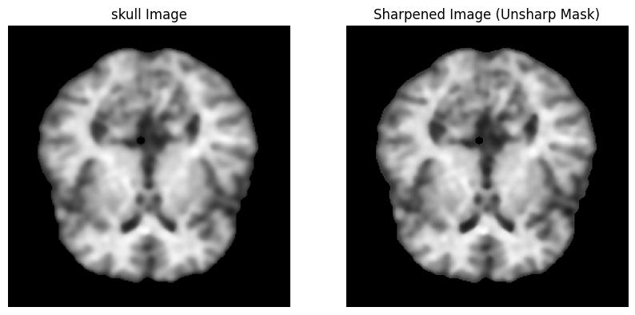

* + Original vs noisy vs enhanced image:

**We can get better result if we decreased the used high rate noise.**

**For AI:**

* + First we import samples from the dataset (1k images for each class) then we applied some preprocessing on them then passing the results **(clear data)** to the three models as we shown in AI flow graph before.
  + Displaying the Classification report for the three models:

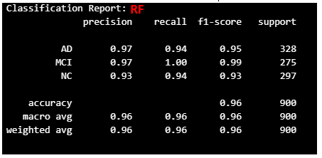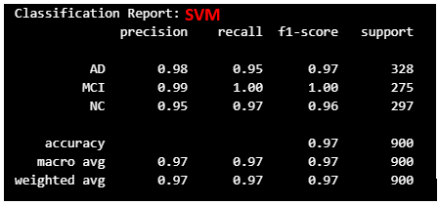

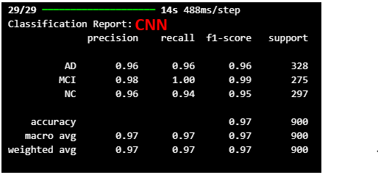

* + 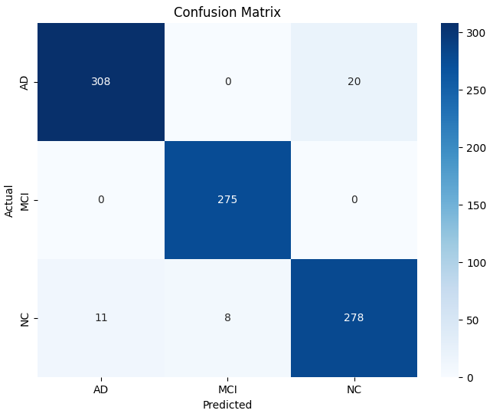Also we displayed the confusion matrix for more visualization of the results:

**RF**

**SVM**

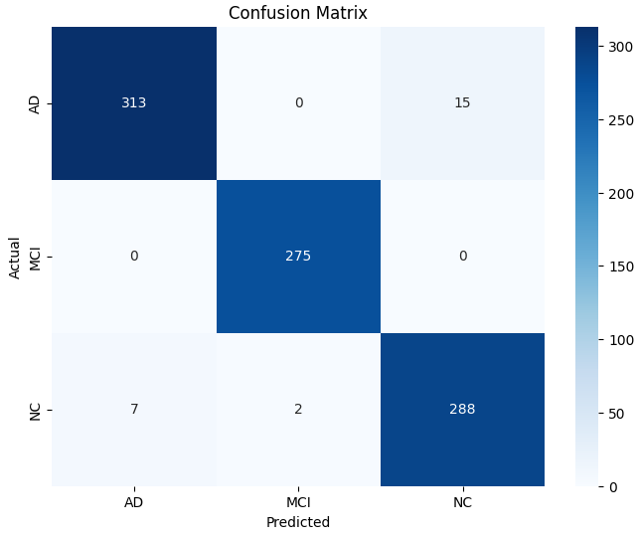

**CNN**

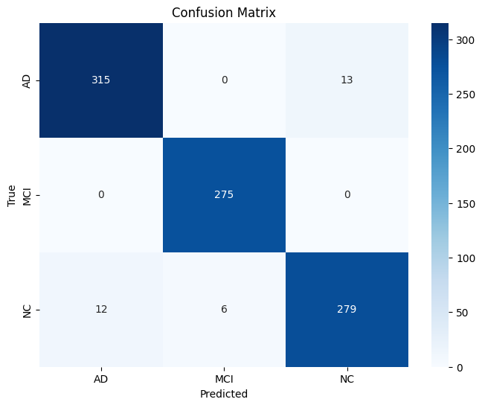

**Discussion and Next Steps:**

As we can see, we were able to retrieve an image that is very similar to the original image by applying the proposed method of successive filters, as it was difficult and perhaps impossible for the AI ​​model to extract any features from these images with dense noise. Also, in the AI ​​stage, we can summarize the results of comparing different models for the same (original) input images as follows:

|  |  |  |  |  |
| --- | --- | --- | --- | --- |
| Model | Accuracy | AD - Precision | AD - Recall | Training time |
| SVM | 97% | 98% | 95% | 5 min |
| RF | 96% | 97% | 94% | 8 min |
| CNN | 97% | 96% | 96% | 1.7 hour |

It is clear that almost all of them have the same result, and as we mentioned, we will pay more attention to recall, as we are very interested in diagnosing Alzheimer's. It is not a big problem if a healthy person is diagnosed as having the disease. With follow-up, it will become clear that he is healthy, but it is a problem if we do not discover the person with Alzheimer's, because delaying treatment causes many repercussions.

So which model do we choose? It is clear that it is better to choose SVM as it achieved high results in a short record time compared to CNN as it got higher recall but consumed a lot of time.

Early judgment on choosing the model will be a bad decision because we have not yet tested the noisy and enhanced images so let's postpone that decision in the final report.

**In the next step, we will pass the original images, noisy image, and enhanced images to the AI ​​models and compare the final results after training the three models on the full dataset.**

**Conclusion:**

**IP part:**

* Median Filter achieved the highest PSNR (25.47) and SSIM (0.48). This makes it the most effective for Salt-and-Pepper noise and general noise reduction while preserving structural details.
* The Gaussian Filter performed slightly better than the Bilateral Filter in terms of PSNR, but it struggled with SSIM, indicating some loss of structural information.
* The Bilateral Filter maintained edges but had lower overall metrics compared to the other two techniques.
* We combined these filters to get highest PSNR (25.49) and SSIM (0.51).

**AI part:**

* All three models achieved high accuracy, precision, and recall.
* CNN had the highest recall, did not need to extract features manually, and did not apply any techniques to improve learning and accuracy, but it took a long time to train.
* CNN, while taking longer to train, demonstrated strong performance, especially in handling noisy images and complex feature extraction.
* SVM and RF, while efficient, might be less robust in handling noisy images and nonlinear relationships.
* The proposed AI-based approach, leveraging CNNs, shows promising results in detecting Alzheimer's disease from MRI scans.

**References:**

1. **Project Paper based:** <https://journals.plos.org/plosone/article?id=10.1371/journal.pone.0302358>
2. **Dataset:**

<https://www.kaggle.com/datasets/kaushalsethia/alzheimers-adni/data>

1. **GitHub Link:**

<https://github.com/MohamedAbdelfattah-SHA/Alzheimer-s-disease-classification>